IMG_256

### **[点微]同城分类信息**

同城分类信息平台

**模板消息申请与设置**

**第一步：申请模板消息**

[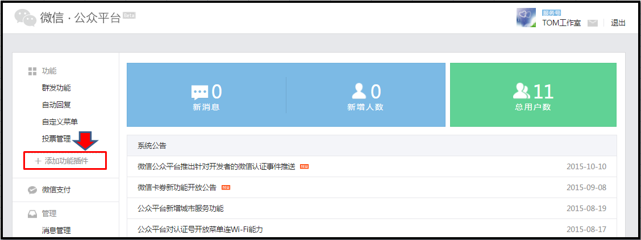](http://www.tomwx.cn/source/plugin/tom_editor/editor/attached/image/20151026/20151026120640_67023.png)

[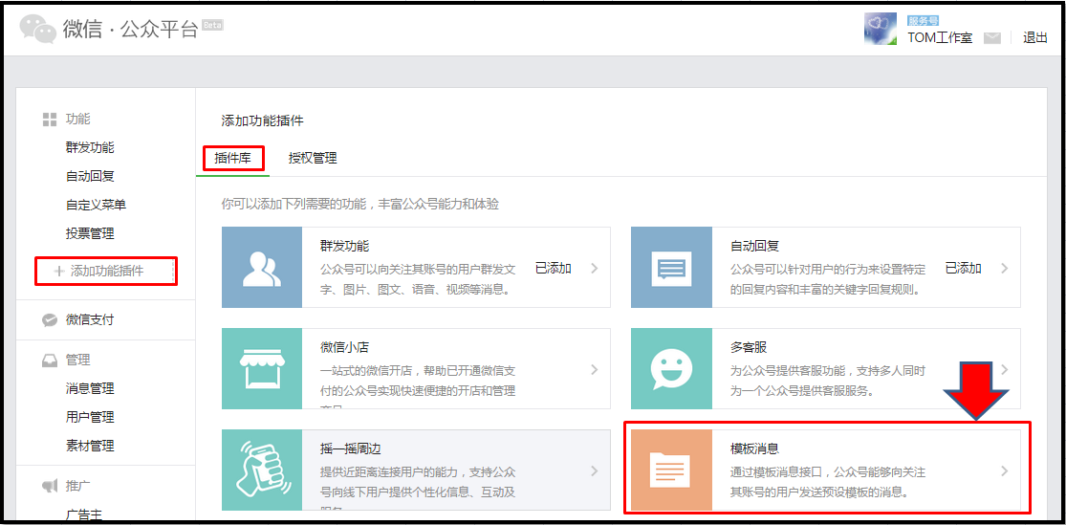](http://www.tomwx.cn/source/plugin/tom_editor/editor/attached/image/20151026/20151026120717_39204.png)

[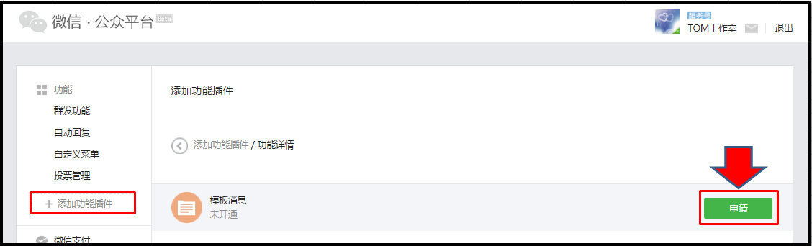](http://www.tomwx.cn/source/plugin/tom_editor/editor/attached/image/20151026/20151026120802_81049.png)

[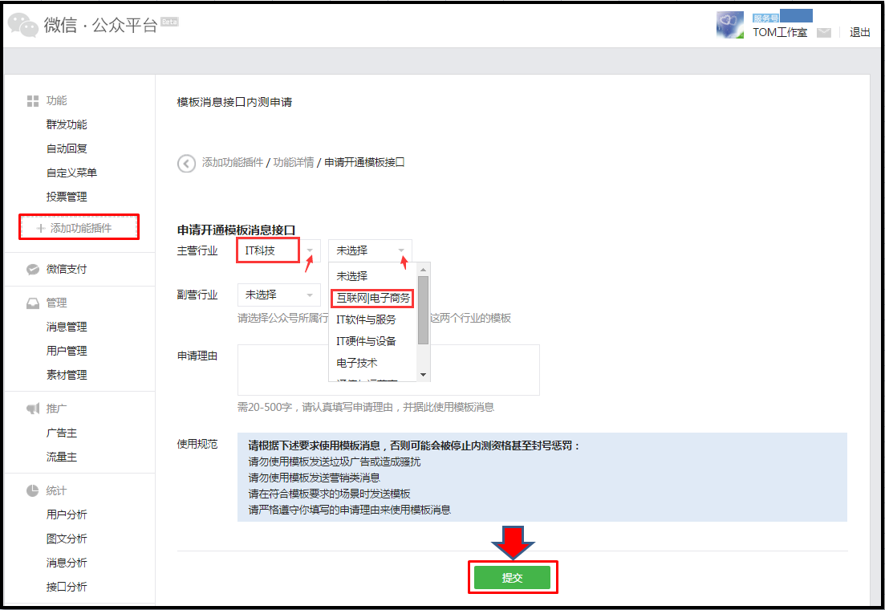](http://www.tomwx.cn/source/plugin/tom_editor/editor/attached/image/20151026/20151026181916_42815.png)

**第二步：添加模板**

[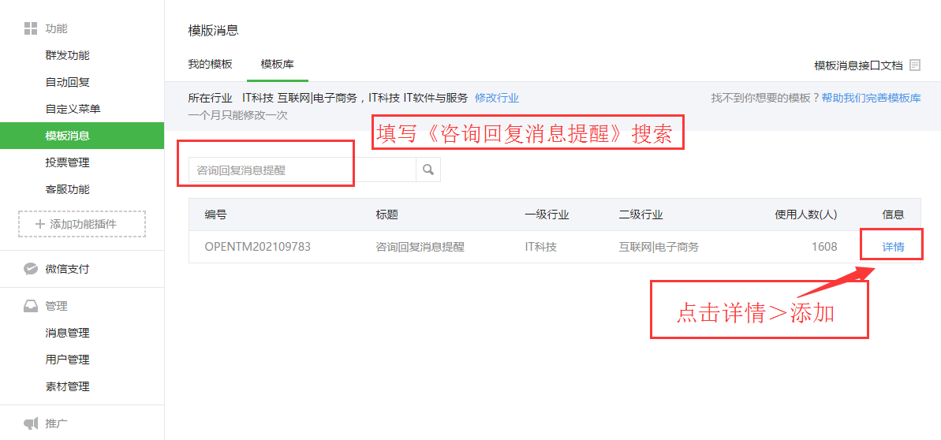](http://www.tomwx.cn/source/plugin/tom_editor/editor/attached/image/20170411/20170411022830_22669.png)

[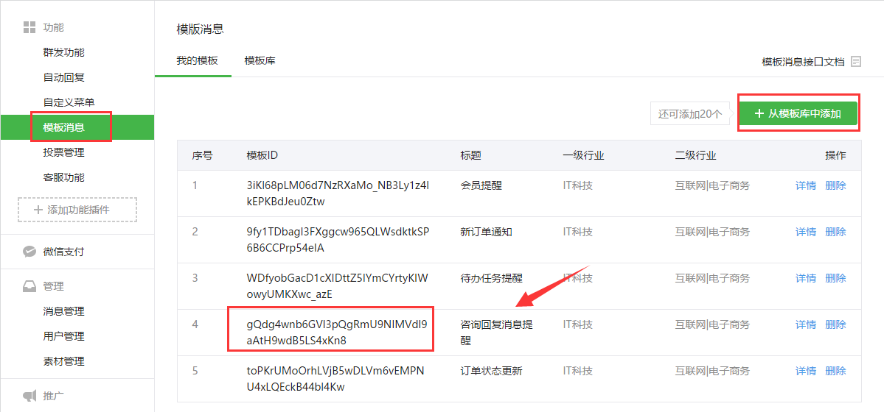](http://www.tomwx.cn/source/plugin/tom_editor/editor/attached/image/20170411/20170411022915_70167.png)

[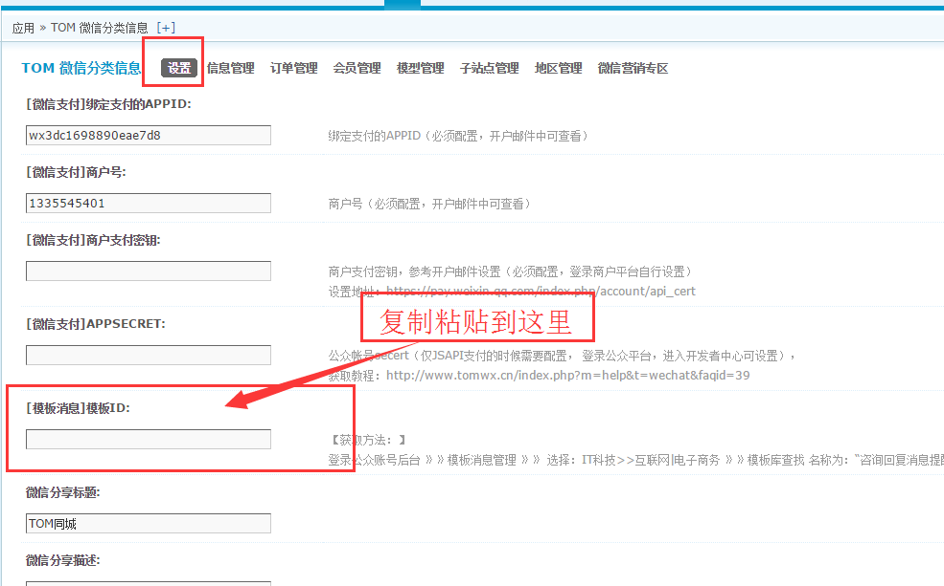](http://www.tomwx.cn/source/plugin/tom_editor/editor/attached/image/20170411/20170411022936_57845.png)